**Name: Bade, Ivan Alexis B.  
Section & Year: 3rd year BSIT  
Date: September 28 2024**

**Terminal**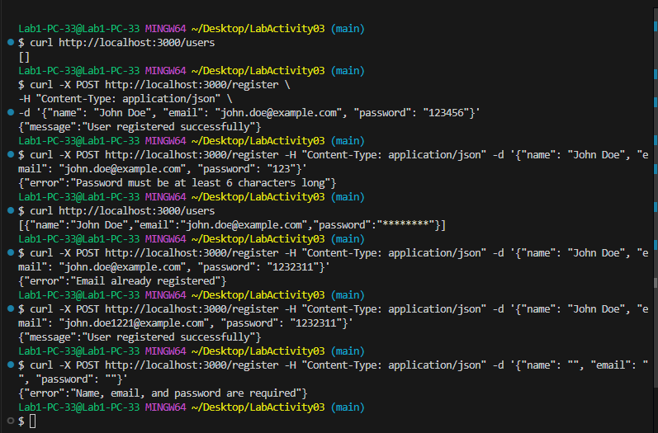

**Code**

